The Early Roots of Inequality:
SES Differences in Solicited and Unsolicited Oral Participation
in Preschool Classrooms

Authors: S. Goudeau¹*, C. Sanrey¹, F. Autin¹, N. M. Stephens², H. R. Markus³, J-C. Croizet⁴.

Affiliations:
¹Centre de Recherches sur la Cognition et l’Apprentissage, Université de Poitiers, CNRS
²Kellogg School of Management, Northwestern University
³Department of Psychology, Stanford University

⁴Université Clermont Auvergne, CNRS
*Correspondence to: sebastien.goudeau01@univ-poitiers.fr

Abstract:
Investigating the existence of inequalities at the very first stage of schooling, we propose that language interactions in preschool produce an unequal oral participation of children as a function of their socioeconomic status (SES). We used a video recording and coding device to observe and quantify children’s and teachers’ verbal language interactions in real preschool classrooms (N = 1236 observations from 98 children). Our findings show that compared to upper-middle-SES children, low-SES children are less likely to be called on, as well as less likely to “take the floor” (i.e., speak without being asked to) during collective exchanges. Furthermore, when they speak, they speak for a shorter time. These results suggest that preschools do not offer equal opportunity for the development of language ability.
One Sentence Summary: Video recording of preschool classrooms reveals SES inequalities in solicited and unsolicited in oral participation.

In many countries, socioeconomic status (SES) powerfully impacts academic achievement: The lower a student’s SES, the more likely they are to experience difficulties and drop out of school before attending university (1). This influence of SES is observed very early during development. Compared to low-SES children, upper-middle-SES children have better verbal skills at the age of 2 (2); they also possess more knowledge of the sounds and names of letters as well as a higher level of familiarity with books at the age of four (3-5).
Preschool, despite important differences in its availability and form across countries, is designed to reduce these initial inequalities by providing low-SES children with greater familiarity and readiness in speaking, pre-reading, and counting. Although early and regular attendance is beneficial for achievement (6), preschool does not seem to level the playing field. Indeed, low-SES children enter first grade still lagging behind upper-middle-SES children in terms of language (oral and written) and counting skills (7-10). These initial inequalities lay the groundwork for understanding subsequent SES differences throughout students’ progression in the educational system. It is therefore critically important to uncover the early root of SES-related inequalities, especially in the educational setting which is a tool aimed at combatting those inequalities. The objective of this paper is to examine why preschool settings fail to level initial SES-related academic disparities.
We propose that one key factor through which preschool settings fuel inequalities is through the oral interactions between teachers and children. Specifically, we argue that those interactions offer unequal opportunity to children from different SES backgrounds to develop their language skills (i.e., frequency and duration of oral participation). We test the hypothesis that compared to upper-middle-SES children, low-SES children are less likely to be called on by the teacher and to “take the floor” (i.e., speak without being asked to or interrupt). Moreover, we predict that, when they speak, they speak for a shorter time than their upper-middle-SES peers.
In preschool, classroom settings value and reward children’s oral participation (11, 12). During language-oriented class sessions (i.e., “circle time”), teachers expect children to share their personal experiences (e.g., “what did you do this weekend?”; “what’s up?”) and to express their opinion and interests (e.g., “what is your favorite activity with your parents?”). During these sessions, the children sit in a circle with the teacher, who gives them a chance to speak. They exist in all French preschools and take place three or four times a day. One key objective of language-oriented class sessions is to reduce social class language inequalities by encouraging all children to speak, but especially those children who are less familiar with the oral language.
Why do these opportunities fail to level the playing field? We theorize that because academic settings value culture-specific forms of language, school knowledge, and ways of being that are closer to the cultural dispositions shaped in upper-middle-SES families than those developed in low-SES families (13-17), low-SES children will participate less during language-oriented class sessions. Indeed, in these settings, children are expected to use their voice to express their own opinions and interests and share personal experiences. Although upper-middle-SES parents typically invite their children to express themselves during family’s daily interactions, this is at odds with how children are socialized in low-SES contexts (15, 18-22). Moreover, the knowledge, skills and personal experiences that are valued and rewarded in those settings are closer to those common among upper-middle-SES families (15, 23). For instance, upper-middle-SES children are more likely than their low-SES peers to have their parents reading stories to them, play educational games at home, travel, or go to museums and libraries (13, 15). These upper-middle-SES parental practices familiarize children with school curriculum and forms of language and give them valuable experiences to share with their peers and teachers.
Previous research has documented that, in primary school and university, the experience of a cultural mismatch between what is valued and expected in academic settings and what students are familiarized with at home creates a discomfort, a low sense of belonging, lower engagement and lower academic performance (17-18). In this paper, considering the existence of this cultural mismatch between family’s experiences and preschool’s expectations, we propose that low-SES children will speak less than their upper-middle-SES peers during language-oriented class sessions. First, because low-SES children tend to start school while being less practiced with verbally expressing their thoughts and feelings, having fewer family experiences that fit with teachers’ expectations, and being less accustomed with academic knowledge and skills (e.g., familiarity with books), we expect them to be less likely to “take the floor” (i.e., speak without being asked to or interrupt their teacher and classmates) than upper-middle-SES children (see 12, for qualitative evidence in one classroom). Second, we expect that, beyond the impact of cultural mismatch on children, teachers might also unintentionally give low-SES children fewer opportunities to speak because their knowledge, skills, and personal experiences are less in tune with what teachers value and expect in the classroom (e.g., talking about a visit to a museum). More specifically, we predict that low-SES children are less likely than their upper-middle-SES peers to be solicited by the teacher during language-oriented sessions. Finally, we predict that, when they express themselves (after being solicited or not), low-SES children “hold the floor” for a shorter time than their more advantaged peers.
To examine this hypothesis of an unequal oral participation, we used quantitative methodology to accurately quantify the frequency and duration of children’s oral participation. To overcome the limitations inherent to online natural observations, we video-recorded students and teachers’ interactions during language-oriented class sessions and then coded specific aspects of behavior using the software The Observer XT (24). This software makes it possible to record and code a variety of behaviors than can occur simultaneously or consecutively over a very short period of time (e.g., children interrupting each other) and produce quantitative data (i.e., frequency and duration). We therefore examined oral participation by quantifying both the frequency and duration of (1) unsolicited participation (i.e., children take the floor by speaking without solicitation) and (2) solicited participation (i.e., preschoolers speak after being called on by the teacher).
These two categories of oral participation were measured by coding five behaviors: (1) unsolicited participation, which refers to (a) speaking without being called-on, (b) interrupting another child, and (c) interrupting the teacher; and (2) solicited participation, which refers to (a) speaking after being called on and (b) speaking after being called on again for a follow-up question. Documenting the number of times children can speak as well as speech duration provides a complete overview of the opportunity children have to develop their language skills. In summary, we tested the following hypotheses:
H1: Low-SES children are less likely than their upper-middle-SES peers to “take the floor”- that is, to speak without being called on by the teacher (H1a), to interrupt another child (H1b), and to interrupt the teacher (H1c).
H2: When they are not solicited, low-SES children are less likely than their upper-middle-SES peers to “hold the floor”, that is, to speak for a shorter time without being called on by the teacher (H2a), after interrupting another child (H2b), and after interrupting the teacher (H2c).
H3: Low-SES children are less likely than their upper-middle-SES peers to be called on by the teacher (H3a), and less likely to be called on for follow-up (H3b).
H4: When they are solicited, low-SES children are less likely than their upper-middle-SES peers to “hold the floor”, that is, to speak for a shorter time after being called-on (H4a), and after a follow-up question (H4b).
Participants included 98 preschoolers from 4 classrooms of Grande-Section, the last year in French preschools before first grade (47 girls, 51 boys; mean age = 5.79 years old, SD = 0.40). Between 8 and 19 language-oriented sessions were observed in each classroom (M = 12.5; SD = 4.80), for a mean duration of 23 minutes and 23 seconds per session (SD = 8 minutes and 47 seconds). A total of 1236 observations were coded. In the sample, 43 children were categorized as low-SES and 51 as upper-middle-SES (SES information was not available for 4 children). The proportion of low- vs. upper-middle-SES did not differ across classrooms, (χ² = 0.66, p = .658). Supplementary Materials contain additional information regarding the material, the procedure, the coding of oral participation and the coding of SES.
Results
The analyses were performed using the software program R (Version 3.4.3) (25) and the packages “sandwich” (26), “fixest” (27-28) and “lmtest” (29). Data were analyzed with a generalized linear model with classroom-period fixed-effects. Indeed, observations are nested in sessions of observation and classrooms, thereby violating the assumption of independence of residuals. In such a case, multi-level models can be used but they produce biased estimates with low numbers of higher-level units (30-31). Therefore, we performed fixed-effects models that remove all classroom-period variations and estimate the within classroom-period effects of SES on oral participation. We computed clustered standard errors to further account for the stratification of the data. We performed regressions with contrast-coded SES as a predictor (32), comparing low-SES children (coded -0.5) and upper-middle-SES children (coded +0.5). Frequency of oral participation was analyzed with a negative binomial regression to account for the distribution and overdispersion of the outcomes. Duration was analyzed with linear regression. Furthermore, complementary analyses were computed to control for the possible effect of gender (female coded +0.5, male –0.5) and oral French academic level (score from 1 = low level to 4 = high level), which showed that the effects of SES presented below are stable even when controlling for these two variables (see Supplementary Materials for the report of these analyses). Correlations between the five measured behaviors are presented in table S1, and the adjusted means and standard deviations are reported in table S2 (see Supplementary Materials).
Frequency of unsolicited oral participation (H1).
Number of occurrences children speak without being called on (H1a). The negative binomial regression on the occurrences of children speaking without being called on revealed that low-SES children spoke about 1.71 times less often than their upper-middle-SES peers, IRR = 1.71, p < .001, 95% CI = [1.49; 1.97], confirming H1a (see Fig. 1A and table S2 in Supplementary Materials).
Number of occurrences children interrupt another child (H1b). Low-SES children interrupted another child about 1.74 less often than their upper-middle-SES peers, IRR = 1.74, p < .001, 95% CI = [1.45; 2.08], confirming H1b (see Fig. 1B and table S2 in Supplementary Materials).
Number of occurrences children interrupt the teacher (H1c). Low-SES children interrupted the teacher about 1.79 less often than their upper-middle-SES peers, IRR = 1.79, p < .001, 95% CI = [1.51; 2.12], confirming H1c (see Fig. 1C and table S2 in Supplementary Materials).
Duration of unsolicited oral participation (H2).
Mean speech duration (in seconds) without being called on (H2a). Low-SES children spoke significantly less per occurrence of oral participation without being called on by the teacher (M_{adjusted} = 1.66, SD = 4.46) than their upper-middle-SES peers (M_{adjusted} = 4.04, SD = 8.97), b = 1.93, SE = 0.45, p < .001, confirming H2a (see Fig. 1D and table S2 in Supplementary Materials).
Mean speech duration (in seconds) after interrupting another child (H2b). Low-SES children spoke significantly less per occurrence of oral participation after interrupting another child (M_{adjusted} = 0.49, SD = 0.91) than their upper-middle-SES peers (M_{adjusted} = 1.15, SD = 2.22), b = 0.54, SE = 0.12, p < .001, confirming H2b (see Fig. 1E and table S2 in Supplementary Materials).
Mean speech duration (in seconds) after interrupting the teacher (H2c). Low-SES children spoke significantly less per occurrence of oral participation after interrupting the teacher (M_{adjusted} = 0.66, SD = 1.24) than their upper-middle-SES peers (M_{adjusted} = 1.51, SD = 3.13), b = 0.66, SE = 0.16, p < .001, confirming H2c (see Fig. 1F and table S2 in Supplementary Materials).
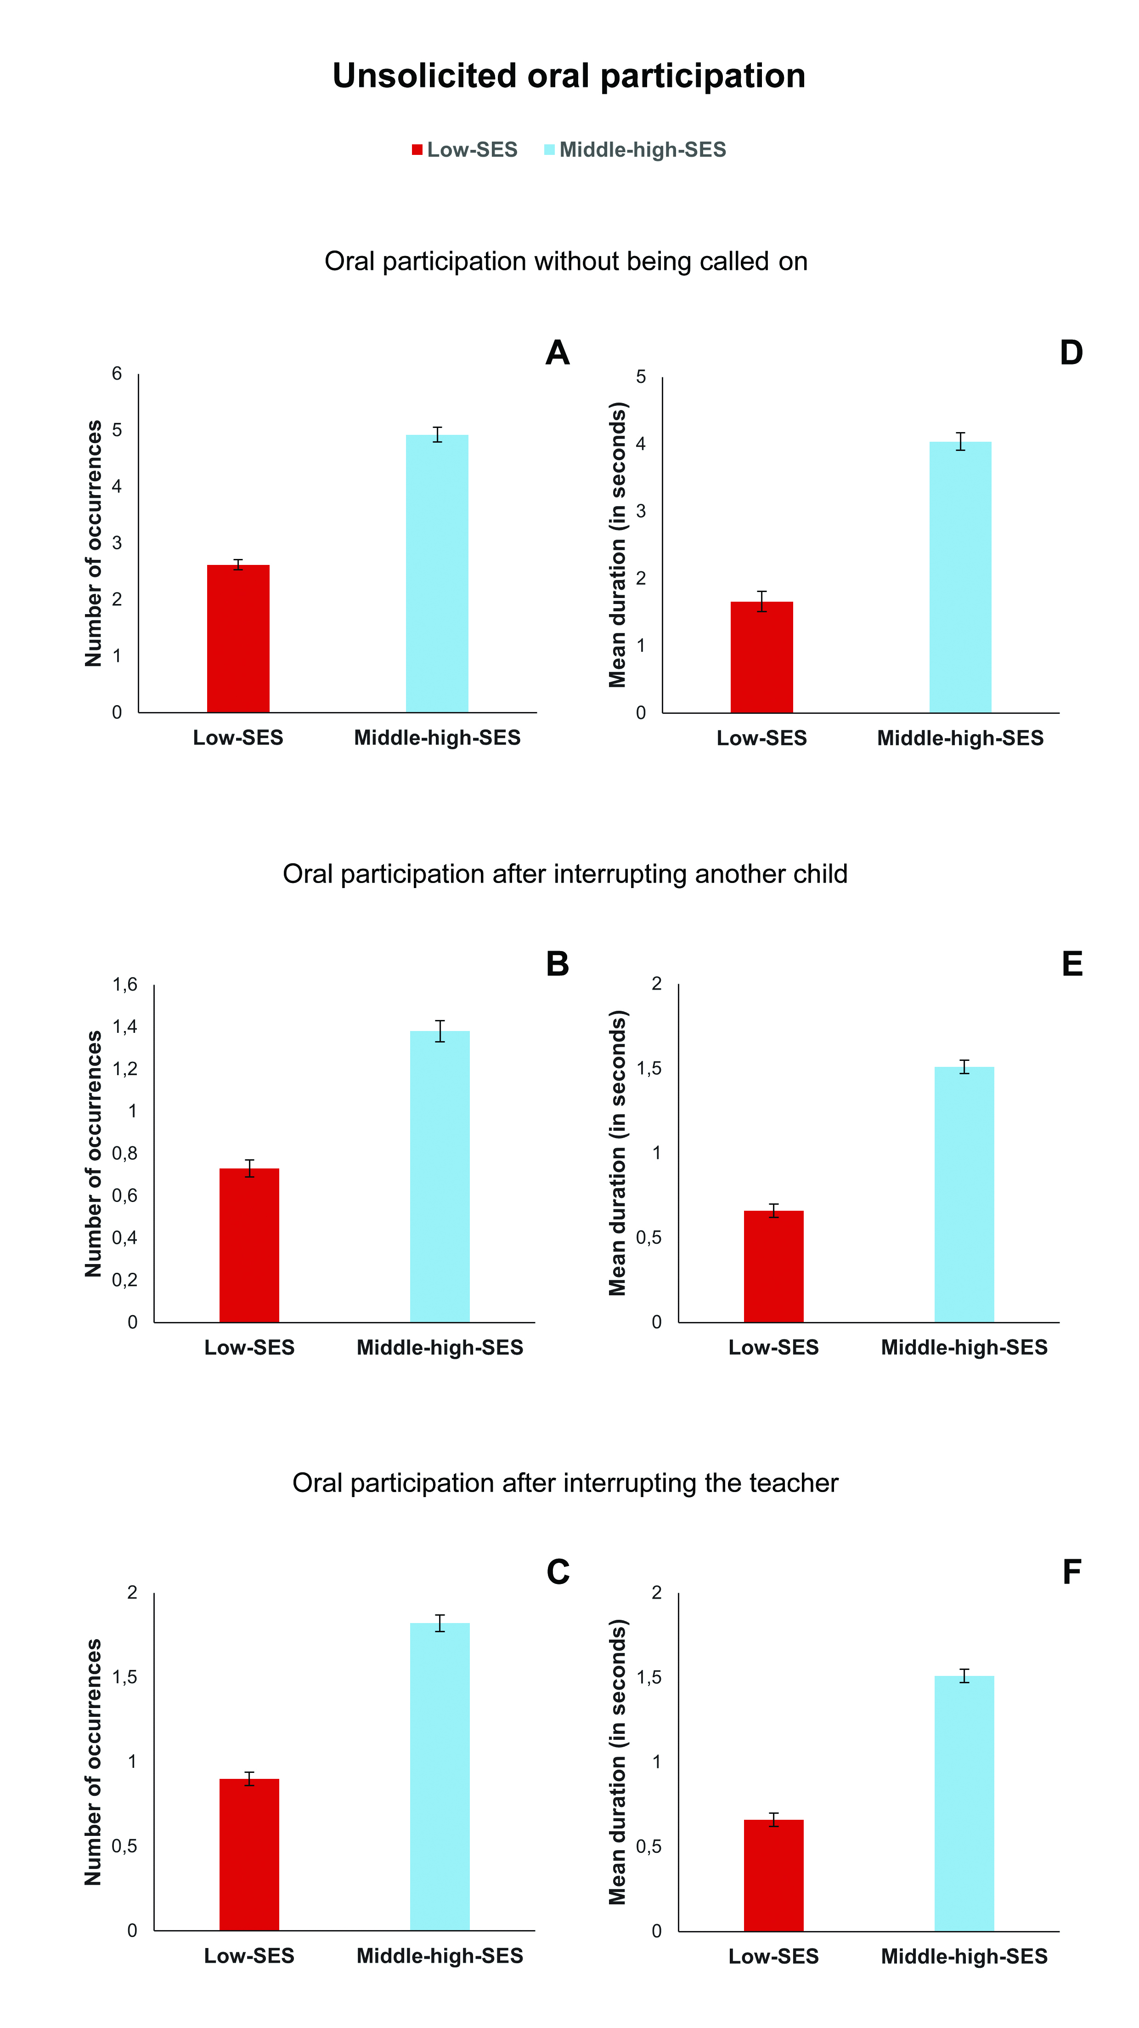
Fig. 1. Unsolicited oral participation. Occurrences (A, B and C) and mean duration in seconds (D, E and F) of unsolicited oral participation according to SES. Reported scores correspond to predicted mean at the observation and child levels. Error bars represent ± 1 SE.
Frequency of solicited oral participation (H3).
Number of occurrences children speak after being called on (H3a). Low-SES children spoke about 1.46 times less often after being called on by the teacher than upper-middle-SES children, IRR = 1.46, p < .001, 95% CI = [1.29; 1.67], confirming H3a (see Fig. 2A and table S2 in Supplementary Materials).
Number of occurrences children speak after being called on again for follow-up (H3b). Low-SES children spoke about 1.42 less often after being called on again for follow-up than upper-middle-SES children, IRR = 1.42, p = .007, 95% CI = [1.10; 1.83], confirming H3b (see Fig. 2B and table S2 in Supplementary Materials).
Duration of solicited oral participation (H4).
Mean speech duration (in seconds) after being called on (H4a). Low-SES children spoke significantly less per occurrence of oral participation after being called on by the teacher (M _{adjusted} = 3.40; SD = 5.71) than upper-middle-SES children (M _{adjusted} = 7.86; SD = 18.1), b = 3.68, SE = 1.00, p < .001, confirming H4a (see Fig. 2C and table S2 in Supplementary Materials).
Mean speech duration (in seconds) after being called on again for follow-up (H4b). Low-SES children spoke significantly less per occurrence of oral participation for follow-up (M _{adjusted} = 0.82; SD = 2.36) than upper-middle-SES children (M _{adjusted} = 1.64; SD = 4.06), b = 0.79, SE = 0.20, p < .001, confirming H4b (see Fig. 2D and table S2 in Supplementary Materials).

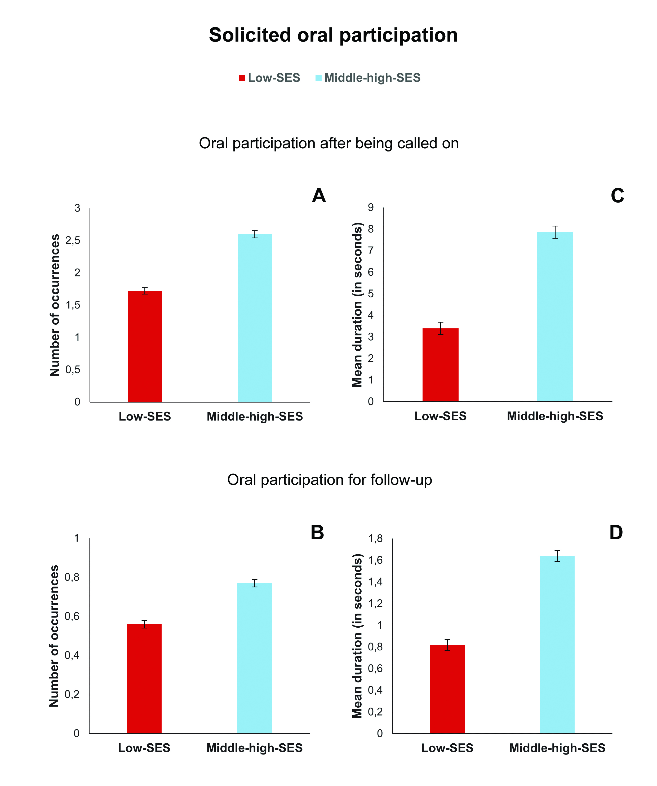
Fig. 2. Solicited oral participation. Number of occurrences (A and B) and mean duration in seconds (C and D) of solicited oral participation according to SES. Reported scores correspond to mean at the observation and child levels. Error bars represent ± 1 SE.

Discussion
Although research has identified various aspects of classroom settings that can play a role in the perpetuation of academic inequalities from primary school to university, few studies have examined the processes by which preschool fails to equalize initial academic disparities between low- and upper-middle-SES children. In this study, our goal was to tackle this important but overlooked question by proposing that preschool settings offer unequal opportunities to develop language skills. Here we provide the first quantitative evidence that language-oriented class sessions create inequalities in oral participation of children from different socioeconomic backgrounds. Indeed, we show that, the frequency of low-SES children’s solicited oral participation is about 40% the one of their more advantaged peers and they “take the floor” about 70% of what their upper-middle-SES peers do. Moreover, when low-SES children speak, they do so for a shorter time.
The thorough observation of oral participation allowed by the recording and double coding provides extended documentation of how SES-related inequalities are perpetuated. We observed that children are not offered the same opportunity to develop their language skills, both in terms of frequency and duration of oral participation. Our results also suggest that inequalities might result from low-SES children restraining themselves from participating but also from teachers who might solicit them less.
Furthering our understanding of the construction of SES-related inequalities at the preschool level is crucial for designing effective interventions and teacher curriculum to minimize the impact of social inequalities. Indeed, by offering less room for oral participation for those who possess less skills, preschool settings might inadvertently hinder the possibility of low SES children to improve their linguistic skills, and thus amplify initial cultural and language differences instead of reducing them. One possible way, that requires empirical investigation, would be to increase teachers’ awareness of the cultural mismatch between family socialization related to SES and school requirements and provide them with strategies to foster equal participation.
This research investigated SES inequalities at the first stage of education – in preschool – by focusing on participation during language-oriented class session in preschool. These collective exchanges in class are intended to help children to develop their language skills, so unequal oral participation reduces the chances of correcting for initial disparities and could fuel lasting subsequent inequalities. This study therefore uncovers early roots of SES-related inequalities, precisely in the educational setting that is thought as a tool to combat these inequalities.
References
1. OCDE, Education at a Glance 2016: OECD Indicators (Éditions OCDE, 2016).
2. S. Grobon, L. Panico, A. Solaz, Inégalités socioéconomiques dans le développement langagier et moteur des enfants à 2 ans [Socio-economic inequalities in the language and motor development of children at the age of 2]. Bull. Epidemiol. Hebdo. 1, 2–9 (2019).
3. J. A. Bowey, Socioeconomic status differences in preschool phonological sensitivity and first-grade reading achievement. J. Educ. Psychol. 87, 476–487 (1995).
4. C. J. Lonigan, S. R. Burgess, J. L. Anthony, T. A. Barker, Development of phonological sensitivity in 2- to 5-year-old children. J. Educ. Psychol. 90, 294–311 (1998).
5. F. Sublet, Y. Prêteur, Les conduites réflexives d’enfants de 5 à 6 ans vis-à-vis des livres de jeunesse [The reflexive behavior of children aged 5 to 6 towards children's books.]. Rev. Fr. Pédagog. 85, 47–54 (1988).
6. F. L. Huang, Does attending a state-funded preschool program improve letter name knowledge? Early Child. Res. Q. 38, 116–126 (2017).
7. M. Colmant, J. P. Jeantheau, F. Murat, Les compétences des élèves à l’entrée en cours préparatoire. Études réalisées à partir du panel d’écoliers recruté en 1997 [Students’ skills at the beginning of preschool. Studies carried out using the panel of pupils recruited in 1997]. Dossiers Eval. Stat. 132, 7-107 (2002).
8. V. Lee, D. T. Burkam, Inequality at the starting gate: Social background differences in achievement as children begin school. (Economic Policy Institute, 2002).
9. E. Maurin, La nouvelle question scolaire. Les bénéfices de la démocratisation [The new school question. The benefits of democratization] (Le Seuil, 2007).
10. T. Rocher, Évolution des inégalités sociales de compétences : une synthèse [Evolution of social inequalities in skills: A synthesis] (CNESCO, 2015).
11. M. Millet, J.-C. Croizet, L’école des incapables ? La maternelle, un apprentissage de la domination [The school for the incapable? Preschool, an apprenticeship of domination] (La Dispute, 2016).
12. J. Streib, Class reproduction by four year olds. Qual. Sociol. 34, 337–352 (2011).
13. B. Bernstein, Class, codes, and control. (London: Routledge, 1975).
14. P. Bourdieu, J. C. Passeron, Reproduction in education, society and culture. (Sage, 1990).
15. A. Lareau, Unequal childhoods: Class, race, and family life. (Berkeley: University of California Press, 2003).
16. N. M. Stephens, H. R. Markus, L. T. Phillips, Social class culture cycles: how three gateway contexts shape selves and fuel inequality. Annu. Rev. Psychol. 65, 611–634 (2014).
17. S. Goudeau, J.-C. Croizet, Hidden advantages and disadvantages of social class: How classroom settings reproduce social inequality by staging unfair comparison. Psychol. Sci. 28, 162–170 (2017).
18. N. M. Stephens, S. A. Fryberg, H. R. Markus, C. S. Johnson, R. Covarrubias. Unseen disadvantage: How American universities’ focus on independence undermines the academic performance of first-generation college students. J. Pers. Soc. Psychol. 102, 1178–1197 (2012).
19. A. Kusserow, American individualisms: Child rearing and social class in three neighborhoods. (Palgrave Macmillan, 2004).
20. P. J. Miller, G. Cho, Self-esteem in time and place: how American families imagine, enact, and personalize a cultural ideal. (Oxford University Press, 2018).
21. P. J. Miller, G. E. Cho, J. R. Bracey, Working-class children’s experience through the prism of personal storytelling. Hum. Dev. 48, 115–135 (2005).
22. B. B. Schieffelin, E. Ochs, Language socialization. Ann. Rev. Anthropol. 15, 163–191 (1986).
23. B. Lahire, Enfances de classe. De l’inégalité parmi les enfants [Social class childhood. Inequality among children] (Le Seuil, 2019).
24. P. H. Zimmerman, J. E. Bolhuis, A. Willemsen, E. S. Meyer, L. P. J. J. & Noldus, The Observer XT: A tool for the integration and synchronization of multimodal signals. Behav. Res. Methods 41, 731–735 (2009).
25. R Core Team, “R: A language and environment for statistical computing” (R Foundation for Statistical Computing, Vienna, 2019)
26. A. Zeiles, S. Köll, N. Graham, Various Versatile Variances: An Object-Oriented Implementation of Clustered Covariances in R. J. Stat Softw, 95, 1–36 (2020).
27. L. Berge, "Efficient estimation of maximum likelihood models with multiple fixed effects: the R package FENmlm" (CREA Discussion Papers, 2018; https://wwwen.uni.lu/content/
download/110162/1299525/file/2018_13).
28. P. D. Allison, P. Richard, Fixed-effects negative binomial regression models, Sociol. Methodol. 32, 247–265 (2002).
29. A. Zeileis, T. Hothorn, Diagnostic Checking in Regression Relationships.” R News 2, 7–10 (2002).
30. C. J. M. Maas, J. J. Hox, Sufﬁcient sample sizes for multilevel modeling. Methodol. 1, 86–92 (2005).
31. N. Sommet, D. Morselli, Keep calm and learn multilevel logistic modeling: a simplified three-step procedure using Stata, R, Mplus, and SPSS. Int. Rev. Soc. Psychol. 30, 203–218 (2017).
32. C. M. Judd, G. H. McClelland, Data analysis: A model comparison approach (Harcourt Brace Jovanovich, 1989)
33. R. G. Jansen, L. F. Wiertz, E. S. Meyer, L. P. Noldus, Reliability analysis of observational data: Problems, solutions, and software implementation. Behav. Res. Methods. Instr. 35, 391-399 (2003).
34. J. Cohen, A coefficient of agreement for nominal scales. Educ. Psychol. Meas. 20, 37-46 (1960).
35. M.W. Kraus, N. M. Stephens, A road map for an emerging psychology of social class: Psychology of social class. Soc. Personal. Psychol. Compass 6, 642–656 (2012).
36. J. M. Oakes, P. H. Rossi, The measurement of SES in health research: current practice and steps toward a new approach. Soc. Sc. Med. 56, 769–784 (2003).
Acknowledgments: The authors are grateful to the research assistants who coded the videos, particularly to Emilie Guichard; Funding: This research was supported by the grant ANR -19-CE28-0007-PRESCHOOL from the Agence Nationale de la Recherche (France), awarded to Sébastien Goudeau and by the grant Contrat de Projet Etat Région (14e CPER – INSECT – CONTEXTE, Université de Poitiers, France), awarded to Jean-Claude Croizet; Author contributions: Sébastien Goudeau proposed and designed the study, and wrote the original draft of the manuscript. Sébastien Goudeau and Jean-Claude Croizet carried out data collection for the study. Camille Sanrey coded the video observations of the four classrooms (RA performed the second coding). Frédérique Autin and Camille Sanrey analyzed the data. All authors provided feedback on the design of the study and the manuscript; Competing interests: Authors declare no competing interests; Data and materials availability: The coding scheme, data, and R scripts used in the analysis are available on Open Science Framework at the URL: https://osf.io/2xd4u/?view_only=bae22e868a304e7f86f60bd9b4941515. Videos are not available due to restrictions of General Data Protection Regulation rules regarding the anonymity of children.

Supplementary Materials:
Materials and Methods
Material and procedure
Coding solicited and unsolicited oral participation
Coding SES
Supplementary text
Complementary analyses controlling for gender and oral French academic level
Fig. S3
Tables S1 to S3
References (33-36)

